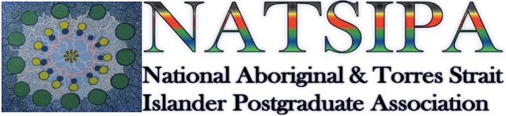

Poster competition – sponsored by

Important dates for the NATSIHEC / NATSIPA poster competition
- Electronic poster submissions are due by noon on Tuesday 15th November
- All competitors must be available to attend and present on Tuesday 22nd and Wednesday 23rd November 2022
- Winners will be announced at the conference on Wednesday 23rd November 2022

Why a poster?
Posters are a great way to present your studies to a wide audience in a short amount of time. They should have enough detail to be of interest to passers-by on their own but not so much text that you scare off your potential audience. Posters should briefly describe your studies for you when you can't be present; however, they are also a really useful way of starting more in-depth conversations about your studies during a conference poster session (perhaps with a future Honours or PhD supervisor, employer, or collaborator!).

Because poster sessions are usually more informal than conference talks and you are usually discussing your studies with people either in small groups or one-to-one, you can get some really useful feedback on your work.

Poster competition prizes
The following prizes will be awarded for both HDR and ECR’s:
- 1st Prise $500
- 2nd Prise $300
- 3rd Prise $200

Poster topics
Aboriginal and Torres Strait Islander HDR and ECR’s should present an aspect of the studies / research they are undertaking.

Poster content
Please note that viewers should be able to read your poster in less than five minutes – if it looks like it will take longer than that, many people won't bother and will choose to move to the next poster instead. Images, diagrams and graphs are a great way to make your studies accessible to an audience with a short attention span.

Posters will often contain the following sections: Title; Introduction and objectives (put your studies in context, draw the reader in – what are you studying and why is it interesting and important?); Methods (a brief description of how the research was/is being undertaken); Results (usually the biggest section, or maybe a number of sections, unless you are in the early stages of your project and so instead describing the issues that you will be considering); Conclusions (potentially including future directions); References; and Acknowledgements (e.g. supervisors or colleagues who have provided useful feedback and/or funders). However, if this doesn't suit your research project, you may prefer not to label your poster sections with these headings.

Poster format
Viewers should be able to read your poster from a distance of at least 1.5 meters.
For both poster competitions, students will be required to submit a pdf file of a poster suitable for printing at A0 size.

Templates

Templates are available on request.

Poster submissions
Electronic poster submissions are due by noon on Tuesday 15th November 2022
Presenters will be required to speak to their poster during the poster presentation session to discuss their research with students, and guests attending the conference; therefore, all competitors must be available to attend the conference and present their poster.

HDR / ECR’s should be prepared to describe their studies in a couple of minutes to interested audience members on the day of the Fair and answer questions about their project. Judges will be circulating amongst the audience and will be assessing each poster presentation for:
- Robustness of research methods and results (or research ideas for undergraduate posters)
- Clarity of presentation, both visual and oral
- Visual appeal – does your poster draw in an audience from a distance?
- Transparency of the relevance of your research – do your results have impact? Are your findings important? Have you made this easy to understand?

Photography and filming
This event may be photographed and/or filmed for the promotional purposes of NATSIHEC / NATSIPA. The images may be posted on NATSIHEC’s or NATSIPA’s website and may be used in publications that are accessible by the general public.

